**ServicePro**

Documentation for Development

* **Creating a New Screen**

1. **Server Project –> Model**

Create a Model based on DB Table

1. **Server Project –> NHibernate –> Mapping**

Create Mapping file based on Model

Like,

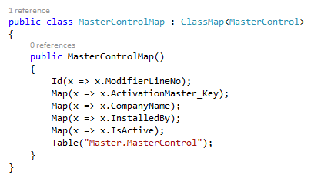

1. **Server Project –> NHibernate –> NHibernateHelper.cs**

Add your Model

Like,

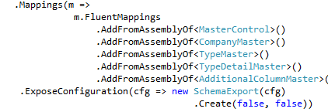

1. **Server Project –> Helper –> GeneralHelper.cs**

* Add your CURD code based on your Model
* Add Get (For getting model based on PK), Get New (Initialize the model) and Set methods (Getting FK Names based on FK Id)
* For Grid if its requires join table, Create a method here else use basic Grid method in Server -> Common

1. **ServicePro –> Controller**

Create a Controller based on your Model

1. **ServicePro –> View**

Create a View based on your View

* **Adding a Save, Delete Method**

1. Create All controls ( Textbox., ) in View based on your Model
2. Create New Script in ServicePro -> Scripts
3. Add Toolbar Action Method in Scripts
4. Create Save, Delete Method in scripts and get all controls values and sends to controller method via Ajax Call
5. Create Save, Delete method in controller and send model to General Helper on what you created on CURD method for that

* **Using Grid**

1. Add Grid Html coding in view

Like,

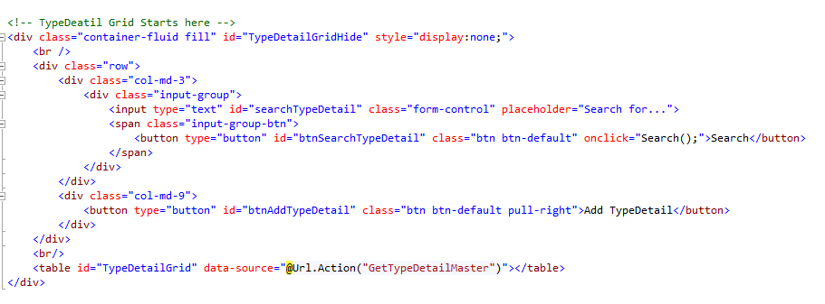

1. Add Script in JS to handle CURD and Searching records, fetching record from DB

Like,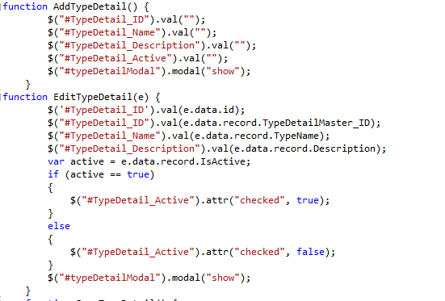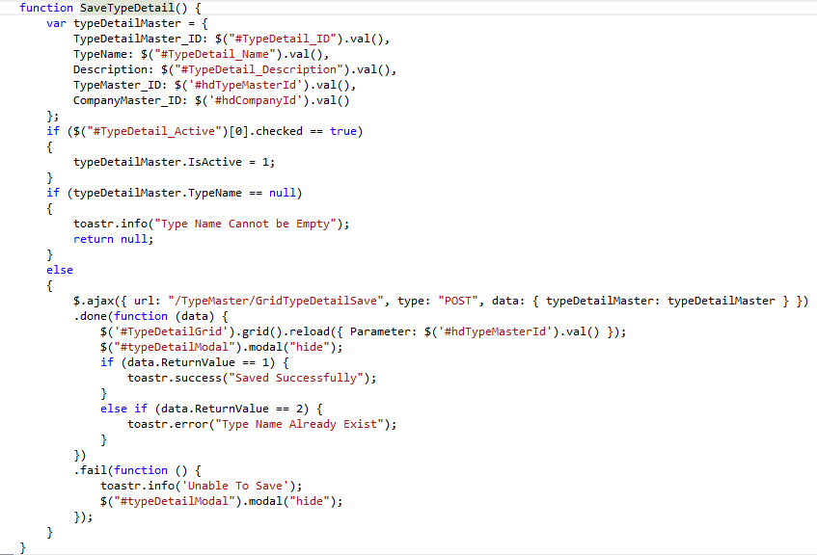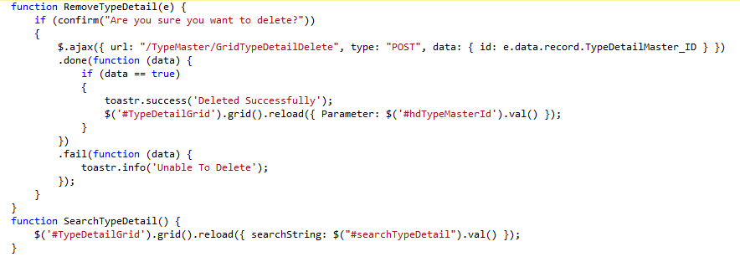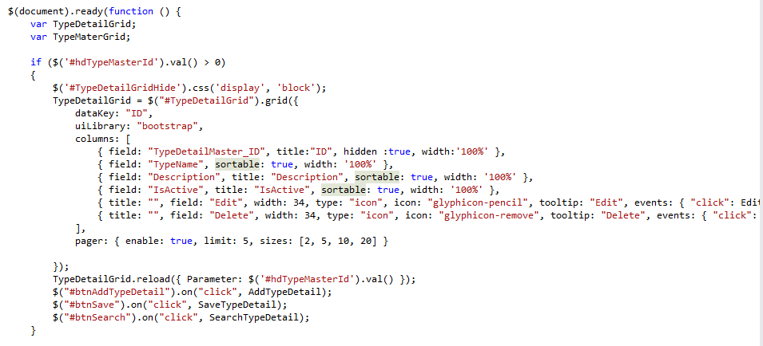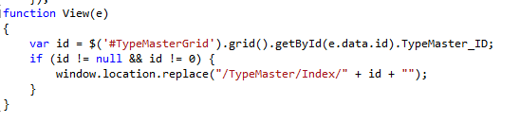

1. Add a Method in Controller to fetch IList for your Grid

* Using Common.FetchGridList ()

For Grid List

* Using Common.GetGridListCount ()

For Getting Grid List Count for paging

1. For Tool bar Action Grid List use Common.FetchList ()

* **Adding Combo Box**

1. Add <select id="cboDataType" style="width:100%;" /> in View
2. Add Ajax calling in script

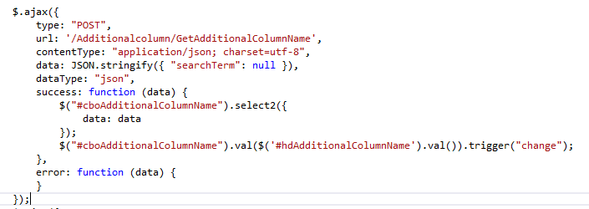

1. Add Method in Controller to fetch combo Box data

(If you want type details class data, use below method to fetch)

